**AGRICULTURE YIELD PREDICTION SYSTEM**

J.Alekhya

*Department of Information Technology*

*Faculty of Gokaraju Rangaraju Institute of Engineering and*

*Technology*

Hyderabad, India

alekya1790@grietcollege.com

B.Shivani

*Department of Information Technology*

*Gokaraju Rangaraju Institute of Engineering and Technology*

Hyderabad, India bandishivaniit2021@gmail.com

***Abstract*—The reliance on historical crop data and environmental factors for yield prediction presents an opportunity to enhance agricultural productivity and sustainability. Our project utilizes machine learning, specifically the Random Forest algorithm, to predict crop yields and recommend high-yield alternatives. By analyzing data such as crop type, soil pH, and rainfall, the system provides accurate predictions and actionable insights. Key processes include data preprocessing for optimal accuracy and the implementation of the Random Forest model for robust analysis. Extensive testing demonstrates the model's reliability in handling diverse datasets, empowering farmers to make informed decisions. This innovative solution not only improves productivity but also promotes sustainable farming practices, addressing critical challenges in agriculture. Through the integration of advanced machine learning techniques, our project underscores the potential of technology to revolutionize decision-making in the agricultural sector.**

***Keywords— Agriculture yield prediction system, Random forest, Machine Learning***

I. INTRODUCTION

Agriculture, as the backbone of India's economy, faces significant challenges from climate change and environmental variability, threatening crop productivity and sustainability. Leveraging technological advancements, the proposed crop yield prediction system aims to address these challenges using machine learning (ML).

The project employs the Random Forest algorithm, a robust and accurate ML technique, to analyze historical data such as weather, soil parameters, and past yields. By predicting crop productivity and recommending high-yield alternatives based on conditions like soil pH and rainfall, the system empowers farmers with actionable insights. Rigorous testing demonstrates its reliability, enabling optimized resource use and improved profitability. This solution highlights the transformative potential of ML in promoting sustainable farming and enhancing decision-making in agriculture.

T.Archana

*Department of Information Technology*

*Gokaraju Rangaraju Institute of Engineering and Technology*

Hyderabad, India archanathota2003@gmail.com

E.Reena

*Department of Information Technology*

*Gokaraju Rangaraju Institute of Engineering and Technology*

Hyderabad, India reenaerukullaa19@gmail.com

The Crop Yield Prediction Project harnesses advanced machine learning technologies to enhance agricultural productivity and sustainability. The core technologies utilized in this project include:

* **Python**
* **Random Forest Algorithm**
* **NumPy** and **Pandas** for data analysis
* **Matplotlib** and **Seaborn** for visualization

This project is structured into several key phases:

* **Data Collection:** Gathering historical data on crop type, weather conditions, soil pH, and rainfall.
* **Preprocessing:** Cleaning and organizing data to ensure accuracy and reliability.
* **Yield Prediction:** Employing the Random Forest algorithm to forecast crop yields based on input attributes.
* **Recommendation System:** Suggesting high-yield crops tailored to specific environmental and soil conditions.

By providing actionable insights, this system empowers farmers to optimize resources, increase productivity, and adapt to changing environmental factors, driving sustainable agricultural practices.

* 1. PROBLEM STATEMENT

Agriculture in India faces critical challenges from climate change and environmental uncertainties, leading to unpredictable crop yields and resource mismanagement. These issues directly impact farmers’ livelihoods and the nation’s food security. The proposed project leverages the Random Forest algorithm, a machine learning technique, to predict crop yields and recommend high-yield alternatives based on factors like soil pH and rainfall. By providing accurate insights and actionable recommendations, this system addresses the unpredictability in agriculture, empowering farmers to optimize resource utilization and improve productivity, ultimately promoting sustainable farming practices.

* 1. SYSTEM DESIGN

Pandas:

Pandas is a Python library used for statistical analysis, data cleaning, exploration, and manipulation. Typically, datasets contain both useful and extraneous information. Pandas helps to make this data more readable and relevant.

Matplotlib:

**Matplotlib** and **Seaborn** are used to create visualizations that help analyze the relationship between features like rainfall and pH with crop yields. **Seaborn** is used for heatmaps and scatter plots, while **Matplotlib** is used to visualize model performance, such as error rates and predicted vs. actual yield comparisons. These visualizations help in better understanding the data and evaluating the model’s accuracy.

NumPy:  
NumPy is a Python library for numerical computing. It provides support for multi-dimensional arrays (ndarray) and a variety of mathematical functions for operations like linear algebra, statistics, and Fourier transforms. Built for high performance, NumPy is the foundation for many other data science and machine learning libraries, enabling efficient data handling and numerical analysis.

Scikit-learn:

Scikit-learn is a powerful Python library for machine learning. Built on top of NumPy, SciPy, and matplotlib, it provides simple and efficient tools for data mining and data analysis. Scikit-learn includes a wide range of algorithms for classification, regression, clustering, dimensionality reduction, and model selection, making it a key tool for developing machine learning models. It also offers utilities for data preprocessing, cross-validation, and model evaluation, enabling easy integration into machine learning workflows.

**RandomForest:**  
Random Forest is an ensemble machine learning algorithm that combines multiple decision trees to improve the accuracy and reliability of predictions. It works by constructing numerous decision trees during training and outputs the average prediction from all the trees, reducing overfitting and increasing model robustness. Each tree in the forest is trained on a random subset of the data, and a random subset of features is used for splitting nodes, which ensures diversity among the trees and strengthens the overall model.

Random Forest is used to predict crop yields based on historical data, including weather conditions, soil pH, and past crop yields. The algorithm processes this data to identify complex patterns and relationships that influence crop productivity. By combining the predictions from multiple decision trees, Random Forest ensures accurate and reliable yield forecasts, helping farmers make informed decisions about resource allocation and crop management. The ability of Random Forest to handle large datasets and manage non-linear relationships makes it an ideal choice for your project, which involves predicting outcomes based on multiple, variable environmental factors.

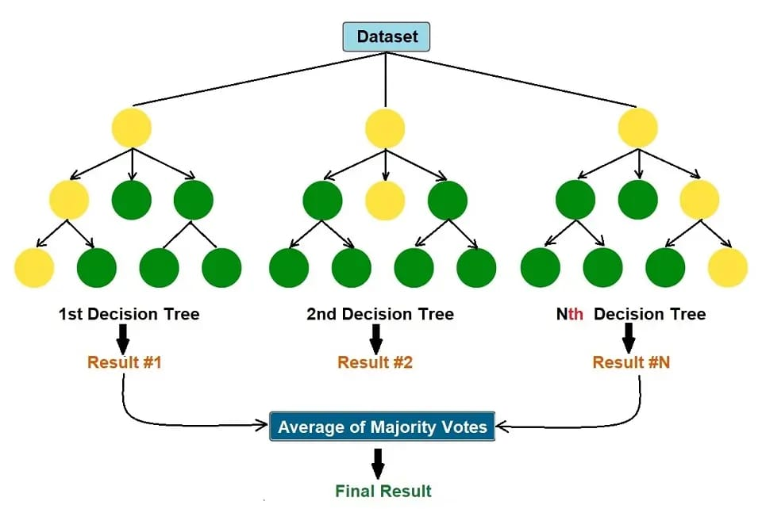

Fig.1. Random Forest

Random Forest is an ensemble learning method that combines multiple decision trees to improve the accuracy and robustness of predictions. It works by training several decision trees on random subsets of the data and using the average prediction from all trees to make the final decision. This approach reduces overfitting and enhances the model’s generalization capabilities.

**How Random Forest Works:**

1. **Data Input:** The model takes input data such as soil pH, rainfall, and past crop yields.
2. **Decision Trees Construction:** The Random Forest algorithm creates multiple decision trees, each trained on a random subset of the input data.
3. **Prediction:** Each tree provides a prediction of the crop yield. The forest then aggregates the predictions from all trees to generate a final, more reliable forecast.
4. **Output:** The model predicts the expected crop yield based on the input features, helping farmers plan better and reduce agricultural risks.

By utilizing multiple trees and random subsets, Random Forest captures complex relationships in the data, making it highly effective for predicting crop yields in your project.

IV SYSTEM ARCHITECTURE

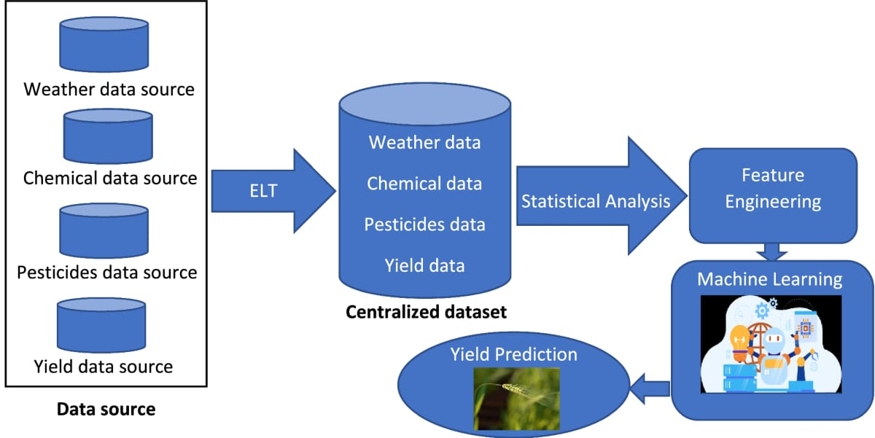

Fig.2. System Architecture

The system architecture for crop yield prediction system can be explained as follows:

1. **Data Collection**: Data from multiple sources such as weather, chemical usage, pesticides, and historical yield data are gathered.
2. **Data Pre-processing**: The collected data is cleaned and transformed to ensure consistency. Missing or incomplete data is handled, and relevant features are selected for further analysis.
3. **Feature Engineering**: The data is analyzed to generate additional relevant features, such as temperature fluctuations, rainfall patterns, and soil parameters, which can help improve the predictive model's performance.
4. **Data Integration**: The transformed data from multiple sources is integrated into a centralized dataset, creating a comprehensive view of the factors influencing crop yield.
5. **Model Training**: Machine learning models, like Random Forest, are trained using the pre-processed data. The models learn to identify patterns between input features (weather, chemicals, etc.) and the target variable (crop yield).
6. **Prediction**: Once trained, the model makes predictions about future crop yields based on new data input (e.g., weather forecasts, soil quality).
7. **Visualization**: The predicted yield values are displayed in a user-friendly manner, helping farmers make informed decisions about their crops.

This architecture allows for accurate and reliable crop yield predictions, empowering farmers to optimize their resource management and improve agricultural productivity.

V. EXPERIMENTAL RESULT

The crop yield prediction system effectively predicted crop yields with high accuracy by leveraging the Random Forest algorithm and machine learning models. The integration of weather, chemical, pesticides, and historical yield data led to precise forecasts, optimizing resource allocation for farmers.

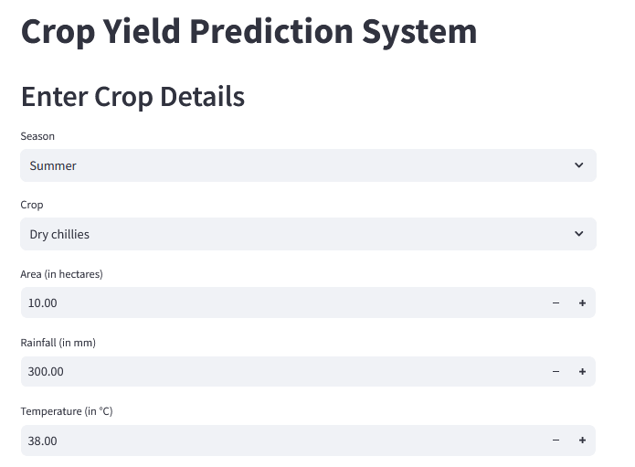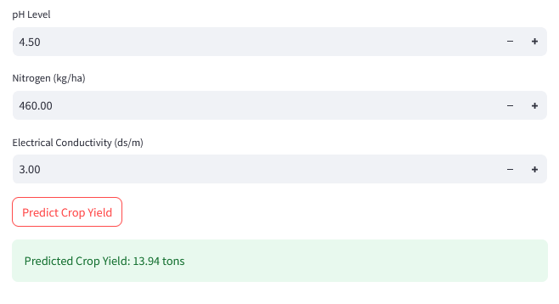

Fig.3. Output

VI. ACCURACY TESTING

Accuracy testing plays a critical role in evaluating the performance of the crop yield prediction and recommendation system. The system's effectiveness is primarily assessed using regression-based metrics such as Mean Absolute Error (MAE), Root Mean Squared Error (RMSE), and R-squared (R²). MAE provides a clear understanding of the average magnitude of prediction errors, without considering their direction, giving a direct measure of prediction accuracy. RMSE, on the other hand, penalizes larger errors more heavily, making it particularly useful for identifying significant deviations in predicted crop yields. R² measures how well the model explains the variance in crop yield data, indicating the model's overall fit and explanatory power. These metrics collectively ensure the model's accuracy and reliability in predicting crop yields and recommending the most suitable crops based on various environmental factors, thereby optimizing agricultural practices.

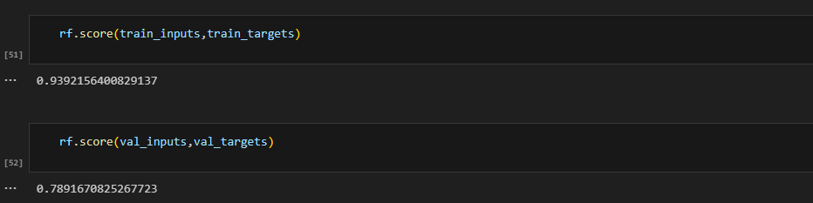

Fig.4. Accuracy Testing

# VII. SYSTEM IMPLEMENTATION

# The system is implemented in Python, using Jupyter Notebook for coding. Various libraries such as NumPy, Pandas, and Scikit-learn were utilized for data processing and analysis. The system leverages the Random Forest algorithm for crop yield prediction, which is trained on historical data, including weather conditions, soil properties, and past crop yields. The model uses this data to forecast the yield of various crops. Additionally, the system includes a recommendation component that suggests high-yielding crops based on specific environmental factors such as soil pH, rainfall, and temperature. The use of machine learning techniques ensures accurate predictions, helping farmers make informed decisions for better resource management and optimized agricultural practices. This solution aims to improve productivity, reduce risks, and enhance the profitability of farming.

# VIII. CHALLENGES

The Crop Yield Prediction and Recommendation System faces several challenges that need to be addressed for accurate and effective results. One of the main challenges is the availability and quality of historical data, as incomplete or inconsistent data can affect the accuracy of predictions. Weather and environmental data can be highly variable, making it difficult to account for all factors that influence crop yield. Additionally, feature selection is crucial; determining the most relevant features, such as soil pH, rainfall, temperature, and historical crop data, is a complex task. The performance of the Random Forest model depends on selecting appropriate features and handling the high dimensionality of agricultural data. Another challenge is ensuring the system can generalize well across different regions with varying climatic conditions, soil types, and farming practices. Finally, providing actionable recommendations for high-yielding crops based on localized conditions requires precise modeling and integration of various environmental factors, making the recommendation system complex and context-dependent.

# IX. CONCLUSIONS AND FUTURE WORK

This project demonstrates the significant impact of machine learning, particularly the Random Forest regressor, in improving crop yield prediction. By utilizing historical data such as weather patterns, soil conditions, and previous yields, the model accurately forecasts crop productivity, enabling farmers to make informed decisions. The integration of a crop recommendation system further optimizes farming practices by suggesting the best crops for specific regions, enhancing yield and reducing risks.

For future improvements, incorporating real-time data, such as soil fertility through IoT devices, could enhance the system's accuracy. Expanding the system to cover all of India would provide a national-scale solution, boosting agricultural efficiency and food security. Continued data integration and system optimization will ensure a long-lasting impact on India's agricultural practices and economy.

# X. REFERENCES

[1] https://ieeexplore.ieee.org/abstract/document/9432236/

[2] https://www.sciencedirect.com/topics/earth-and-planetary-sciences/crop-yield.

[3] https://www.kaggle.com/opencvmlpython/crop-yield-dataset

2017?select=NewCropTrainFinal.csv

[4] Anakha Venugopal, Aparna S, Jinsu Mani, Rima Mathew, Prof. Vinu Williams Department of

Computer Science and Engineering College of Engineering, Kidangoor Kottayam, India (IJERT

2021).

[5] Peter Harrington, Machine Learning in Action (Edition 2017).

[6] Practice - Kaggle: Your Machine Learning and Data Science Community

[7] Flask tutorial - https://www.youtube.com/watch?v=Z1RJmh_OqeA